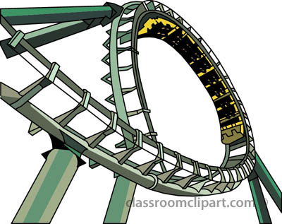
PRIOR INVESTIGATION
Marble-Coaster
Design and Technologies - Year 2 Workbook

Name:____________________ Teacher:_____________________

TASK:
Your task is to design, plan, experiment with and build a cardboard marble rollercoaster. The marble-coaster must be made to consistently deliver a marble from the top of the desk to the finishing box on the floor using cardboard and simple materials. You must work in groups of three to finish your marble-coaster. Your marble-coaster must be exciting and creative!
ACTIVITY 1: Roll a marble down the tube at different angles. Measure how far the marble travelled after being rolled down the tube. Circle which angle made the marble go faster?
A) B) C)

_______________ ________________ _______________
Distance: ________ cm Distance: ________ cm Distance: ________ cm

ACTIVITY 2: Draw a line to predict which way the marble will go.
ACTIVITY 3: Draw a plan to get the marble from the starting spot to the finishing cup. Use lines to represent cardboard runners.

EXTENSION ACTIVITY: Go to http://invention.si.edu/tinker-ball
You must virtually place objects in a way that uses the force of gravity to get the ball into a cup.
REFLECTION: What? So what? Now what?
You must write at least two sentences reflecting on you experiences so far.
What did you do?

So what did you find out?

How will you use this in your marble run?

PLANNING
Materials List:
_______________________________ ____________________________
_______________________________ ____________________________
_______________________________ ____________________________
_______________________________ ____________________________
Labelled Diagram
REFLECTION: What? So what? Now what?
You must write at least two sentences reflecting on your planning and initial construction.
What did you do?

So what did you find out?

How will you use this in your marble run?

TESTING
You must test your marble-coaster five times with a marble. You must watch how your marble-coaster works and write a reflection after the five tests.

What worked well?

What didn’t work well?

How will you fix the problem?

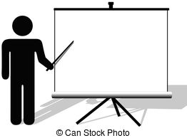
PRESENTATION
Within your group you must complete a 2 minute speech about your marble-coaster. To help plan your script fill out the following information:

Name of your Marble-Coaster: _______________________________________
Materials Used:
_______________________________ ____________________________
_______________________________ ____________________________
_______________________________ ____________________________
_______________________________ ____________________________

How have you used gravity to make the roller-coaster work? (Features of the marble-coaster)

Things you have changed from the first test runs and why?

