**INTRODUCTION**

**STOP-the-PAPER**

**Digital Technologies - Year 4 Workbook**

**Name:____________________ Teacher:_____________________**

**TASK:**

Your task is to come up with a solution to reduce the amount of paper used within the school by using existing information systems. At the beginning of the unit you must record how many times, in one week, you use paper within the classroom and around the school. You must then collate the information and display them digitally three different ways. Using the information you have gathered you must then attempt to find a sustainable solution that reduces the amount of paper used at school using existing information systems.

ACTIVITY 1: What is Sustainability?



ACTIVITY 2: List four ways we can be sustainable in school.

1:____________________________________________________________

2:____________________________________________________________

3:____________________________________________________________

4:____________________________________________________________

ACTIVITY 3: Write down different ways paper is used in the classroom, the school and in the community.

|  |  |  |
| --- | --- | --- |
| Classroom | School | Community |
|  |  |  |

**DATA COLLECTION**

**TABLE 1: Tally mark table**

|  |  |
| --- | --- |
| SUBJECT | Total pieces of paper used |
| Mathematics |  |
| English |  |
| Science |  |
| Music |  |
| Art |  |
| Technologies |  |
| Other |  |

**TABLE 1: Notes about how the paper was used**

|  |  |
| --- | --- |
| SUBJECT | USES OF PAPER |
| Mathematics |  |
| English |  |
| Science |  |
| Music |  |
| Art |  |
| Technologies |  |
| Other |  |

**DATA REPRESENTATION**

ACTIVITY 4: Draw a Column graphs that represents the total pieces of paper used for each subject.

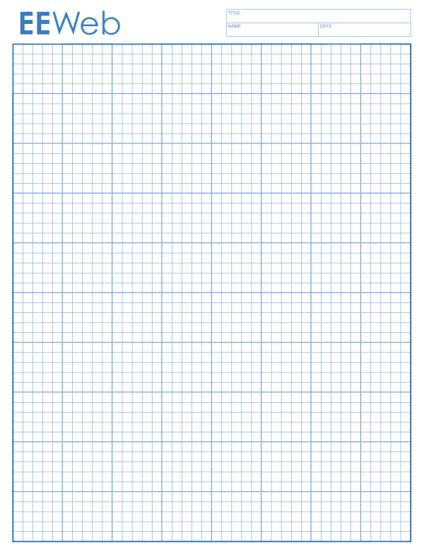GRAPH TITLE: __________________________________

**DATA REPRESENTATION**

ACTIVITY 5: Use word processing software to represent your data digitally, three different ways. Once you have drawn your graphs digitally print two copies out. Give one to your teacher and glue the other into the section below.

**REFLECTION**

*What? So what? Now what?*

You must write at least two sentences, in each section, reflecting on your experiences so far.

What did you do?

So what did you find out?

How will you use this in your Sustainability solution?

**PLANNING**

ACTIVITY 5: Brainstorm all the existing information systems available at the school.

_______________________________ ____________________________

_______________________________ ____________________________

_______________________________ ____________________________

_______________________________ ____________________________

ACTIVITY 6: Use the space below to plan your sustainability solution. You can write the key dot points to your solution, brainstorm ideas or draw a concept map. Once complete, write a good copy on the Laptops.